Question 27: Debugging String Matching Code (Skipped Last Valid Position)
Aim
To identify and fix the bug in the brute-force string matching algorithm, ensuring that every valid starting position of the pattern is checked correctly.

Problem Statement
The given brute-force string matching program fails to examine the last valid starting position of the pattern within the text because of an incorrect loop boundary.
Given Code:
def string_match(text, pattern):
n, m = len(text), len(pattern)
matches = []
for i in range(n - m):
for j in range(m):
if text[i + j] != pattern[j]:
break

if j == m - 1:
matches.append(i)

return matches

Source Code (Corrected)
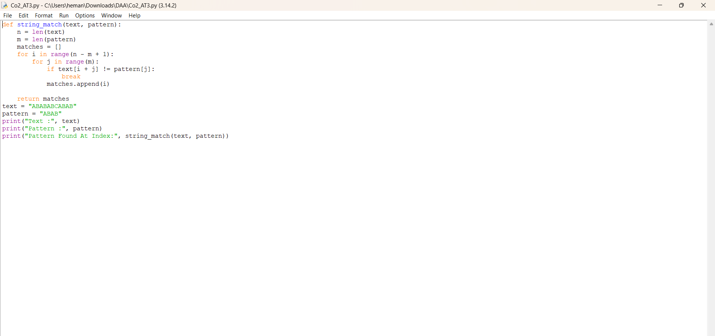
OUTPUT
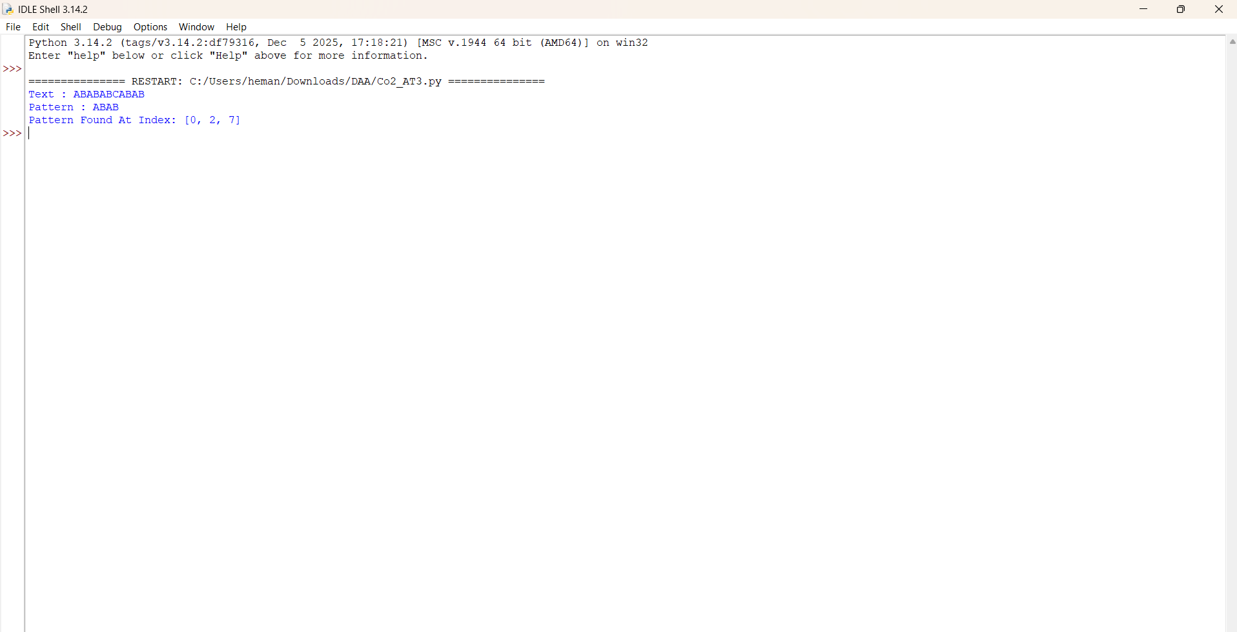
Explanation of the Bug
The original program uses
for i in range(n - m):
The range() function excludes the ending value.
If
- Text length = 10
- Pattern length = 3
then
n - m = 7
The loop executes
0,1,2,3,4,5,6
The valid starting positions are
0,1,2,3,4,5,6,7
The last possible alignment (index 7) is never checked.
Therefore, one possible pattern match is always skipped.

Debugging the Code
The loop should include the final valid alignment.
Incorrect
for i in range(n - m):
Correct
for i in range(n - m + 1):
The +1 ensures that the last valid starting position is also examined.

Improvements Made
- Fixed the loop boundary from range(n - m) to range(n - m + 1).
- Used Python's for...else construct for clearer logic:
  - break exits the loop on a mismatch.
  - else runs only if no mismatch occurred, meaning the entire pattern matched.
- Added descriptive comments to improve readability and maintainability.
- Preserved the original brute-force behavior while making the implementation easier to understand.

Time Complexity Analysis
Let:
- n = length of the text
- m = length of the pattern
Best Case
The first character mismatches at every position.
Time Complexity = O(n)
Worst Case
The pattern matches almost completely at every position before failing (or matches fully).
The algorithm compares the pattern at every valid position.
(n − m + 1) × m
Therefore,
Time Complexity = O(n × m)
Space Complexity
Only a list of match indices and a few variables are used.
Space Complexity = O(k)
where k is the number of matches found (excluding the output list itself, the algorithm uses O(1) auxiliary space).

Conclusion
The original brute-force string matching implementation skipped the final valid alignment because the outer loop ended one iteration too early. By changing the loop to range(n - m + 1), the algorithm checks every possible starting position and correctly identifies all occurrences of the pattern. The corrected implementation maintains the brute-force approach, improves readability with clear comments and a for...else structure, and has a worst-case time complexity of O(n × m).

